Power BI Training: Culminating Exercise

Solutions Manual

Table of Contents

Extract, Transform, Load 3

Loading Data 3

Editing Queries 4

Processing the data 5

data relationships 7

Task #1 8

Creating total consignment of the publishing House 8

Creating the performance of consignment rate 8

Creating year-to-year % growth 9

Creating consignment quantity per grade level 10

Creating consignment contribution for international 10

Creating seasonality trend of consignment and returned 10

Output 10

Task #2 11

Percentage of colored/black and white books by level 11

Quadrant chart on the grade level performance 11

Percentage of color/Black and White books 11

output 11

**Culminating Exercise**

*These solutions serve as a general guide or reference to the functionalities and basics that will be used in creating the exercise to produce the required charts*

# Extract, Transform, Load

## Loading Data

*In creating reports in PowerBI, loading the data is the first step which serves as your source*

1. Click on **Get Data** in the upper section of the interface under the Home tab

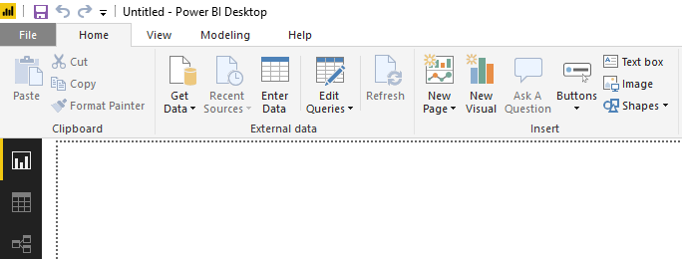

1. Select the Text/CSV data source type in the dialog and then click **Connect**.

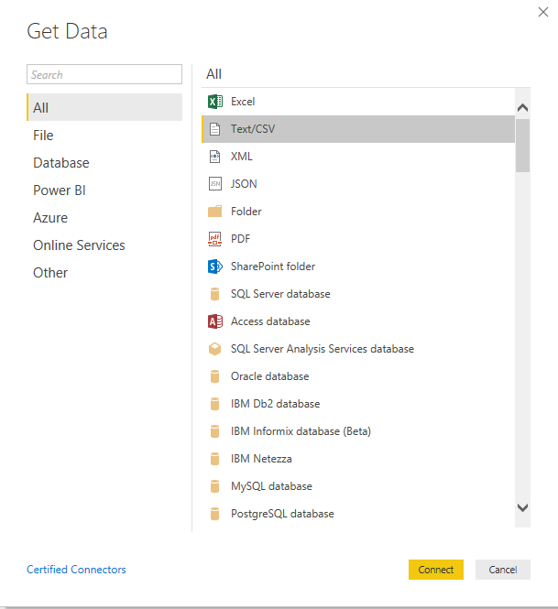

1. Select which tables to add using the *Navigator* pane by clicking on the check beside its name and then click **Load**.

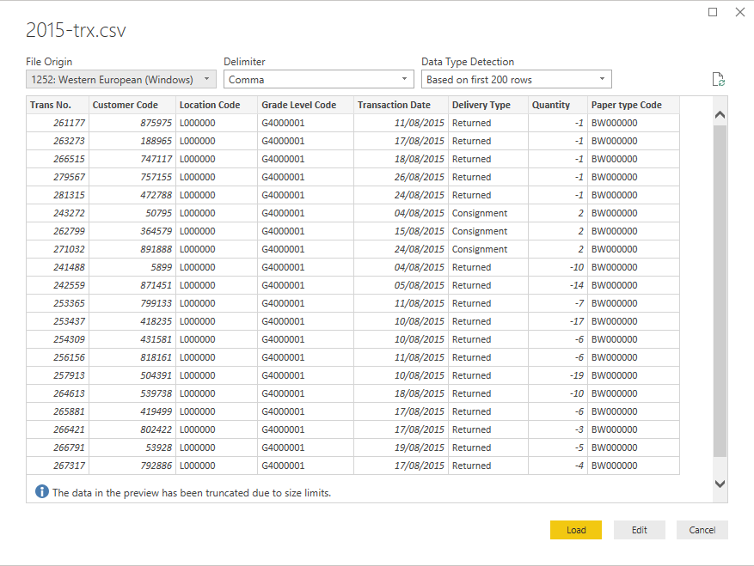

* + To process the datasets, click **Edit**.
  + Then, refer to the next section on *Editing Queries*.

## Editing Queries

1. Load all the datasets from the folder by clicking **New Source**.
   * You need to load the datasets one by one using the same procedure by selecting each of them

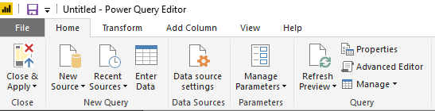

1. There should be 6 data models extracted from your sources:

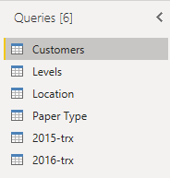

## Processing the data

### Joining the two transactions table (2015 & 2016)

1. Check and validate the column fields of both tables

2015-trx

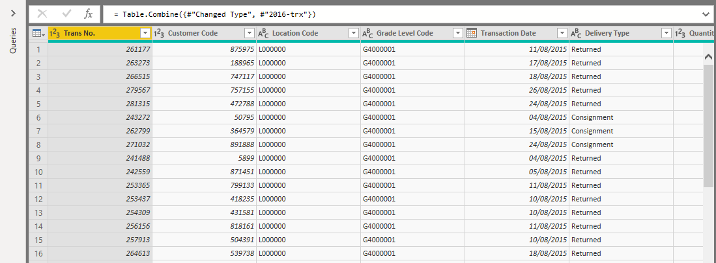

2016-trx

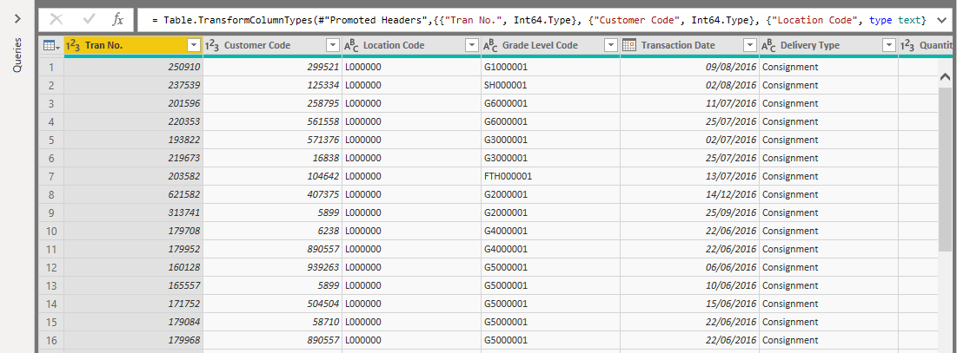

1. Notice that the column field **Trans No.** for 2015 and **Tran No.** for 2016 are not equal

**IMPORTANT:**

When joining two tables, make sure that the column header names of the two tables are the same in order for you to avoid creating duplicate columns

1. Rename the column header **Tran No.** 🡪 **Trans No.** in the 2016-trx data model

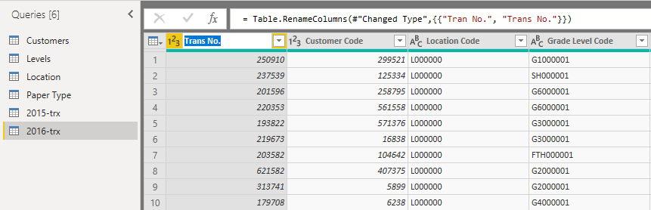

1. In the Home tab, click Append Queries
   1. A window will pop-up asking you how many tables to append.
   2. Select two tables
   3. Select **2016-trx**
   4. Click OK.

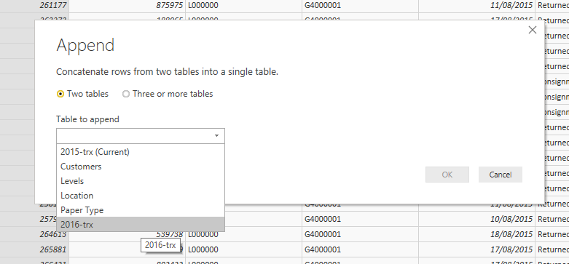

1. Rename the table **2015-trx** into **All-trx** since this contains both transaction tables already.

## data relationships

### Adding Data Relationships

1. Go to the **Relationships View**.
2. Power BI automatically detects relationship between the tables if there are matching column names from them and detects the cardinality.
3. Validate and check for fields that are not set. Drag the column names from the reference table into the transaction table (e.g. Customer Name from the Customers table into Customer Name in the Transaction table)
   * For the transaction table, we’ll use the **2015-trx** table since it’s the appended table that contains the **2016-trx** as well.

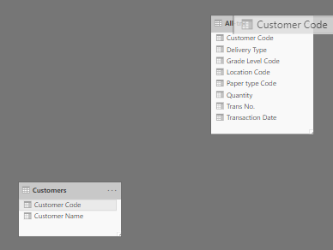

1. Repeat the same steps in establishing relationships for the **Levels, Location,** and **Paper Type** by dragging the column fields.

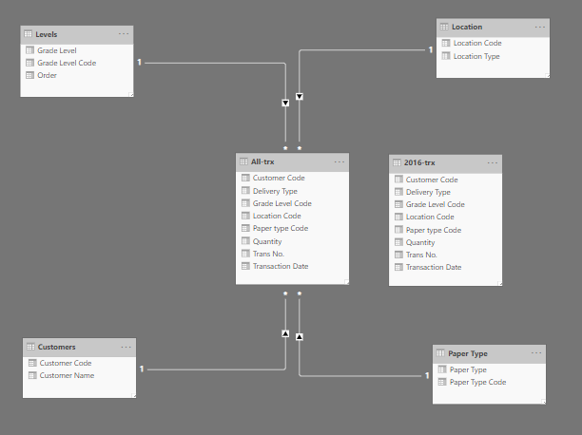

# Task #1

## Creating total consignment of the publishing House

1. Right-click on the All-trx in the Fields pane
2. Select New Quick Measure
3. In the Quick Measures window, select the calculation “Filtered value”

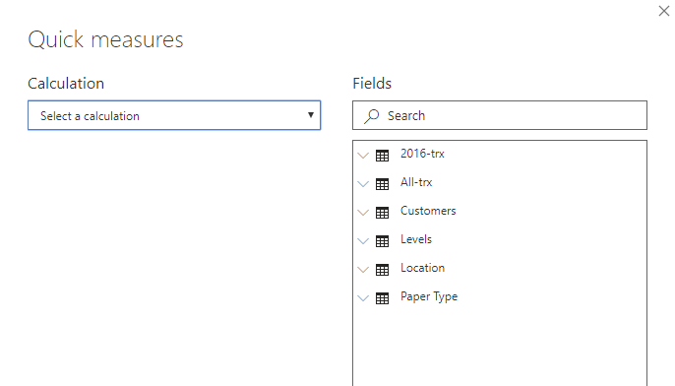

1. Expand the **All-trx** table
2. Drag the column field **Quantity** in the Base Value
3. Drag the column field **Delivery Type** in the Filter
4. Select the value **Consignment**

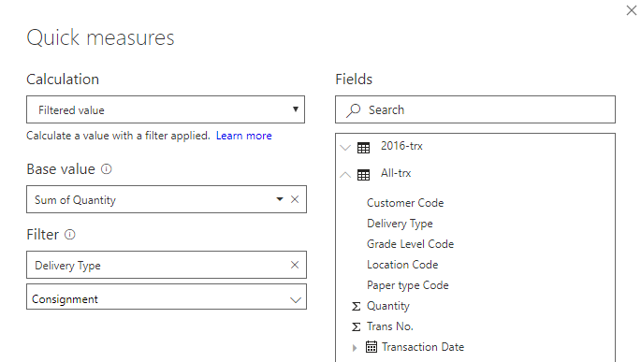

1. Click **OK**.
2. Drag the newly created measure into the reports page and select the card visual

## Creating the performance of consignment rate

*A performance consignment requires two filtered metrics namely: Consignment and Returned. We also need to set the target percentage for consignment which is 80%*

1. Right-click on the All-trx in the Fields pane.
2. Select New quick measure
3. Expand the **All-trx** table
4. Drag the column field **Quantity** in the Base Value
5. Drag the column field **Delivery Type** in the Filter
6. Select the value **Returned**

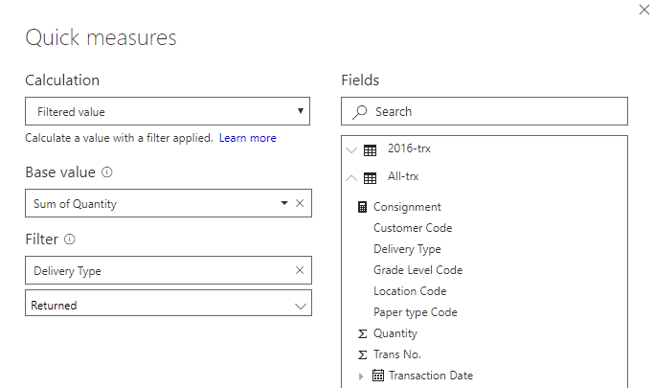

1. Click **OK**.
2. Click on the measure newly created measure **Returned**. Change the formula by adding an ABS syntax outside which looks like this:

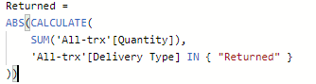

1. On the Field Properties, right-click **All-trx** and select New Measure
2. Type the formula and hit enter:

**% Performance** = $1- \frac{Returned}{Consignment}$

1. Right-click **All-trx** in the Field Properties and select New Measure
2. Type the formula and hit enter:
$$Performance Target=0.80$$

3. Select the gauge chart in the Visualizations pane
4. Drag the **% Performance** into the Value field and the **Performance Target** into the Target value field

## Creating year-to-year % growth

1. Right-click All-trx and select New quick measure
2. Under Time Intelligence, select **Year-over-Year change**
3. Expand All-trx in the field section on the right
4. Drag Consignment into the Base Value
5. Drag Transaction Date into the Date Field

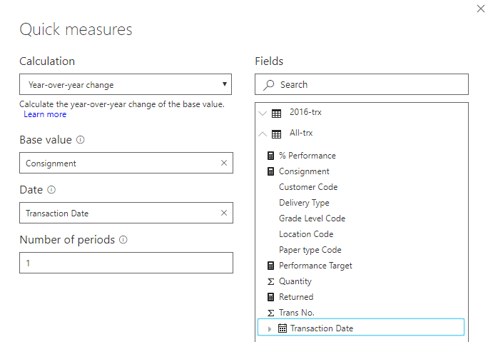

1. Click **OK**.

## Creating consignment quantity per grade level

1. Click on the column stacked bar chart
2. In the Grade level table, drag **Grade Level** into the Axis field
3. In the All-trx, drag **Consignment** into the Values field

## Creating consignment contribution for international

1. Click on the Pie Chart
2. Drag **Consignment** in the Values field
3. Drag **Location Type** found in the Location data model

## Creating seasonality trend of consignment and returned

1. Click on the Area Chart
2. Drag **Consignment** in the Values field
3. Drag **Returned** in the Values field under the Consignment field
4. Click the **Transaction Date** in the All-trx data model
   1. Expand the Transaction Date field
   2. Drag the Month field into the Axis field in the Visualization pane

## Output

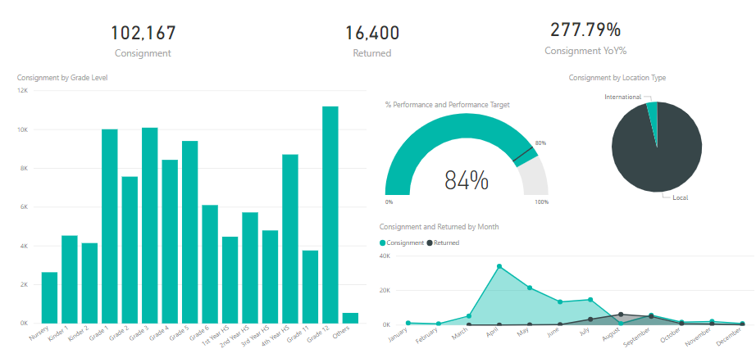

# Task #2

## Percentage of colored/black and white books by level

1. Click on the 100% stacked column chart
2. Drag **Grade Level** field from the Grade level data model into the Axis field
3. Drag **Paper Type** field from the Paper Type data model into the Axis field
4. Drag Consignment field from the 2015 Transactions into the Value field

## Quadrant chart on the grade level performance

1. Click the Scatter Plot chart
2. Drag **Grade Level** from the Grade Level data model into the Axis field
3. Drag **Consignment** into the X-axis
4. Drag **Returned** into the Y-axis
5. To create quadrant lines, go to the Analytics pane
   1. Go to Average Line
   2. Click +Add
   3. Select the Consignment for the Measure
   4. Click +Add again
   5. Select the Returned for the second average line

## Percentage of color/Black and White books

1. Click the Donut chart.
2. Drag **Paper Type** from the Paper Type data model into the Legend field.
3. Drag **Consignment** into the Value field.

## output